**Project Proposal (Solar Eclipse 2017)**

**Project Purpose**

The project I wish to work on will present the users with information about when where and other information about the upcoming solar eclipse going through America this year.

**The Audience**

The audience for this site will be those wishing to see the astrological event from, business owners in nearby areas to tourist just wanting to see something that rarely happens. They are going to want to know what times the event is happening and which cities will give them the best view of the events, others such as business owners will just want to know when the tourist are coming to plan around the increased business.

**Web Pages**

Home page- this will have a brief discription of what the sites about and a video of previouse eclipses.

Glasses for eclips – this will have options for glasses to use and buy to watch the eclipse with links to places to purchase them.

Map of path – this will contain a photo with the path of the eclipse and which zones will be most optimal to watch it.

What is eclips – this will give a laymans explantion of what an eclips is with a photo example.

Idaho falls – this will contain a photo of the eclipse and how close to the sweet spot it is along with data taken from json file for the time the eclipse will happen and for how long.

Rexburg - this will contain a photo of the eclipse and how close to the sweet spot it is along with data taken from json file for the time the eclipse will happen and for how long.

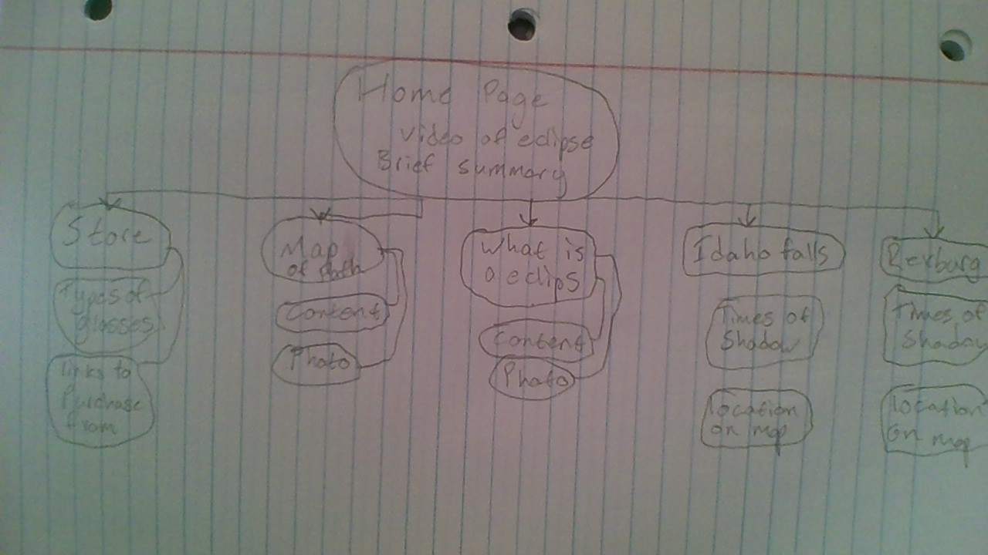

**Wireframe Sketches**

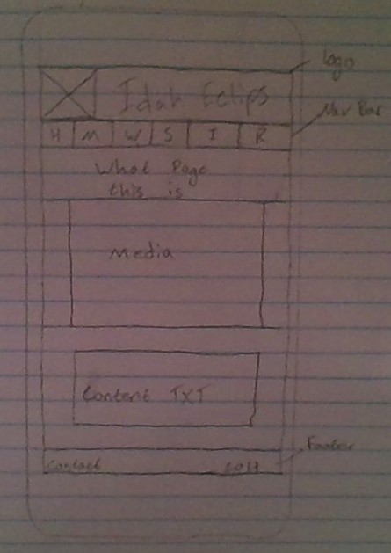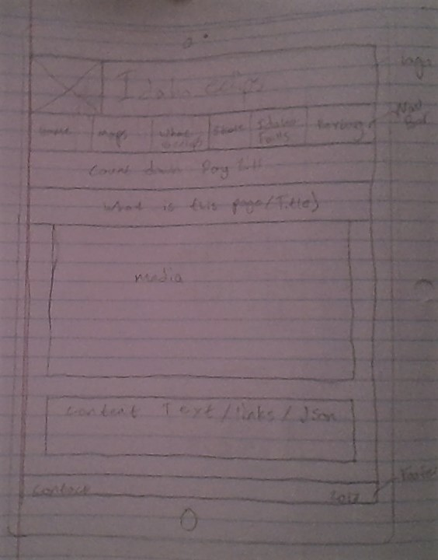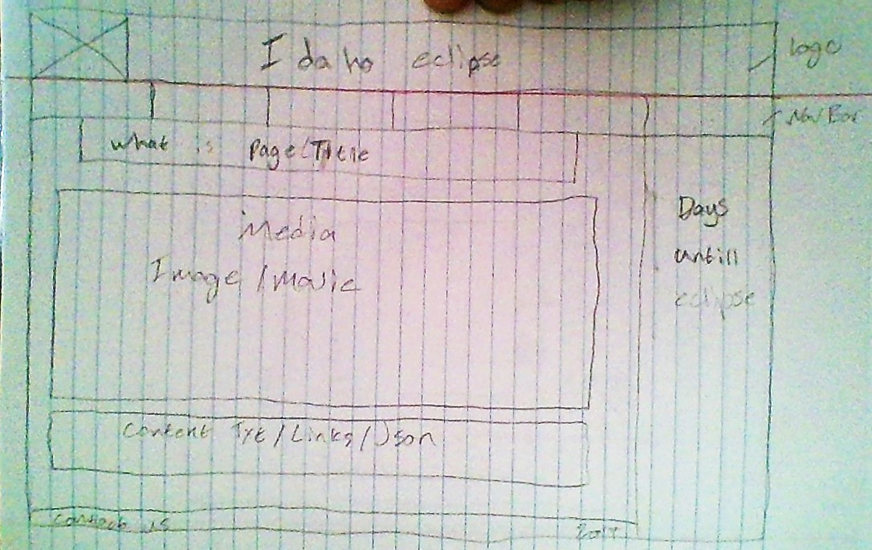

**Usability Concepts**

The first thing that I will do is make sure that my wireframe follows the guideline with these factors in mind following which I plan to have it reviewed by a classmate to see if anything’s missing before starting by looking at the wireframe. After creating the home page which will have the basic layout of the site in place I can then repeat the same steps again and run the wave tool from my browser to see if there is anything it suggest to be added before continuing to add the other pages to the site.